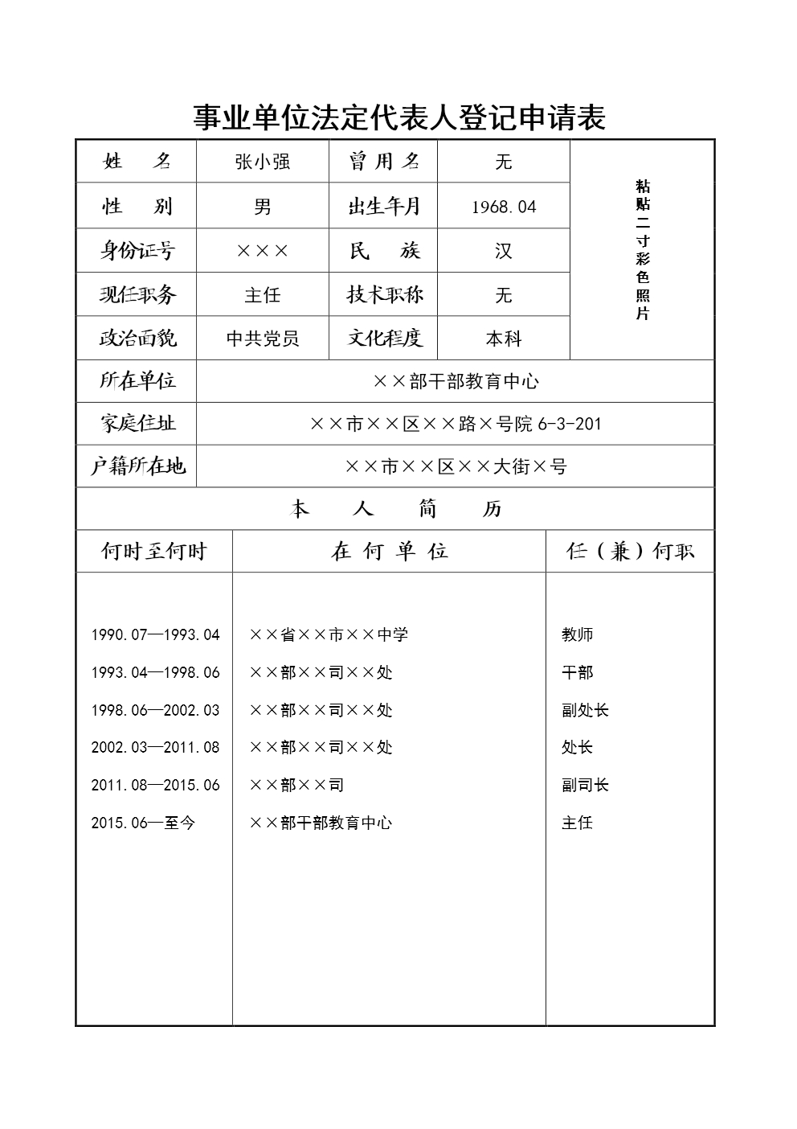

[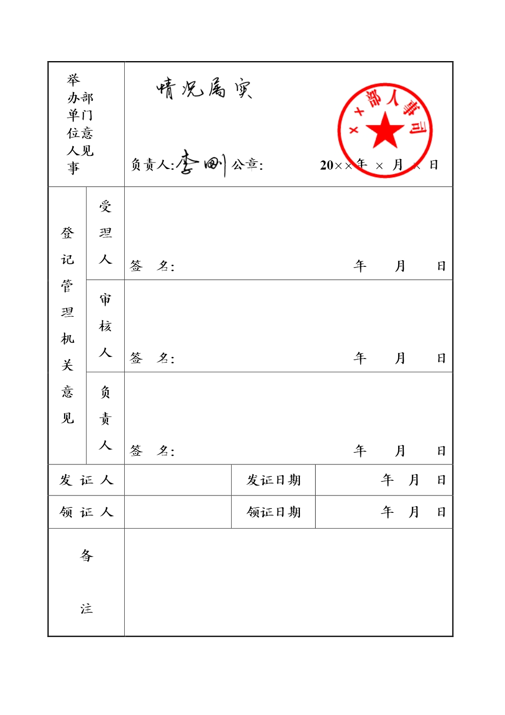](http://www.gjsy.gov.cn/djglsl/201512/W020160531433239152548.jpg)