[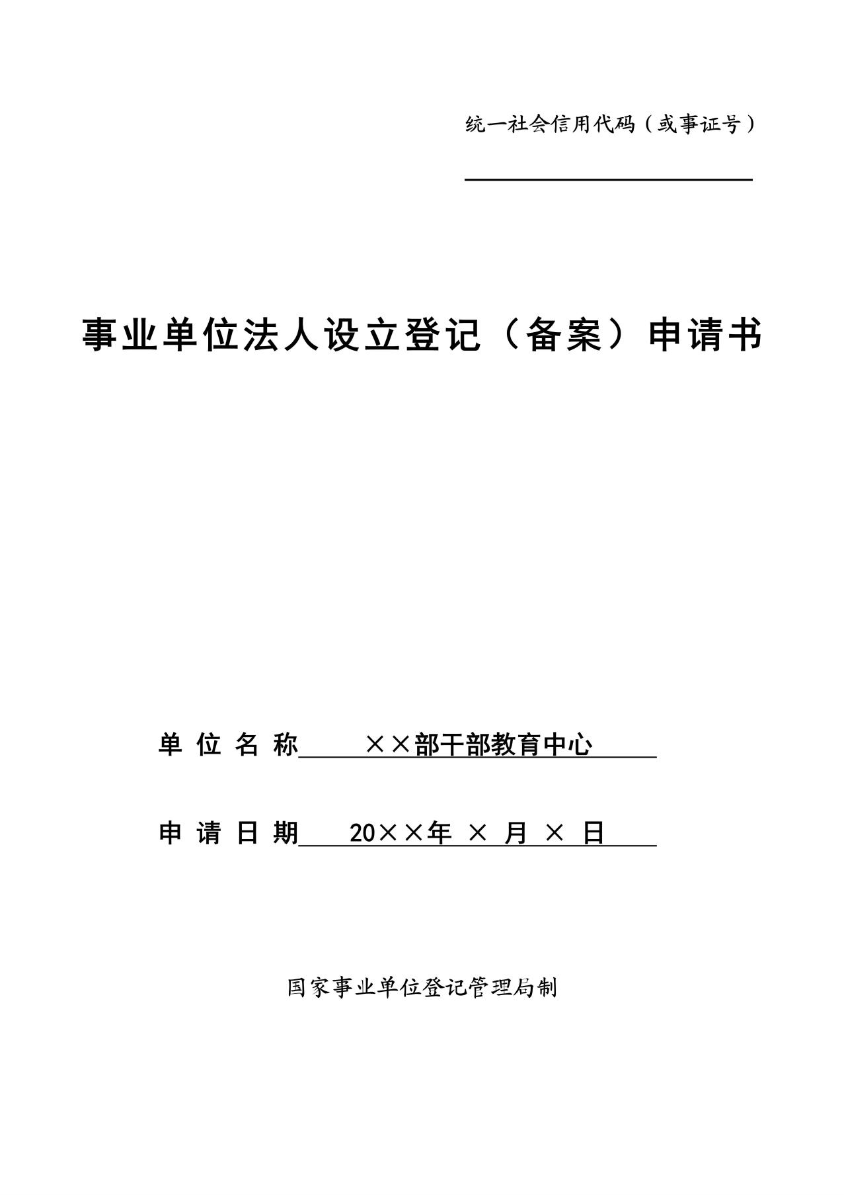](http://www.gjsy.gov.cn/djglsl/201512/W020160531430155719425.jpg)

[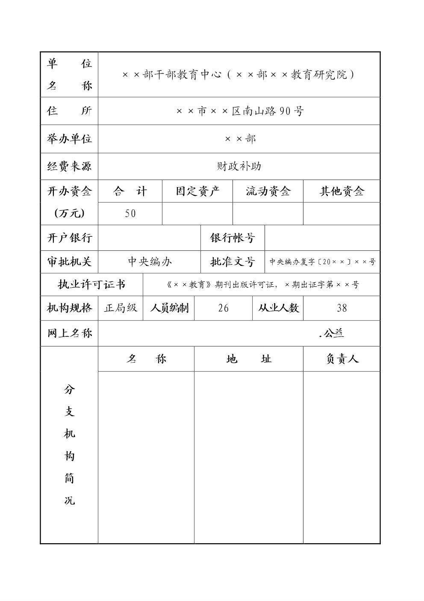](http://www.gjsy.gov.cn/djglsl/201512/W020160531430155774310.jpg)

[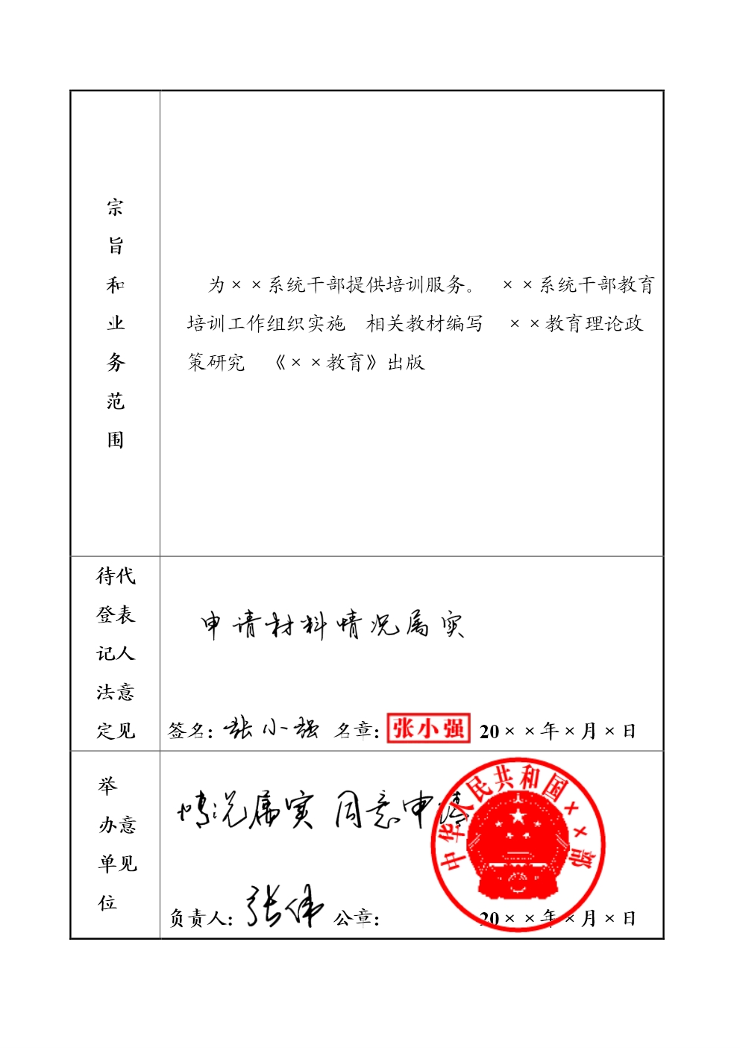](http://www.gjsy.gov.cn/djglsl/201512/W020160531430155799129.jpg)

[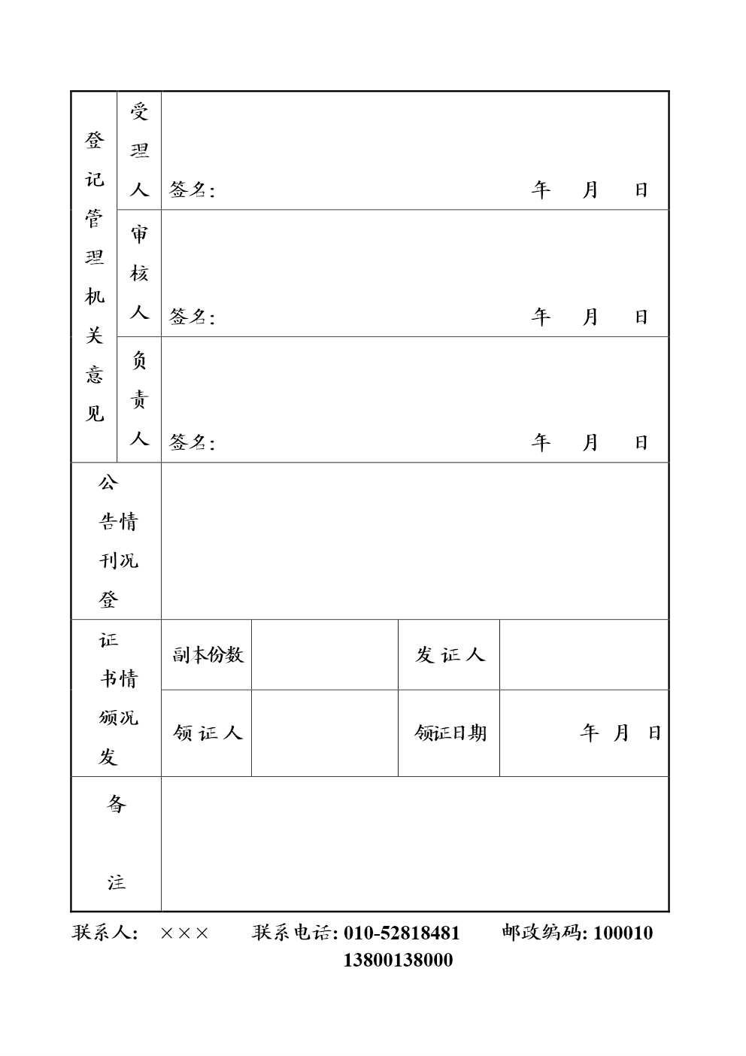](http://www.gjsy.gov.cn/djglsl/201512/W020160531430155815094.jpg)