[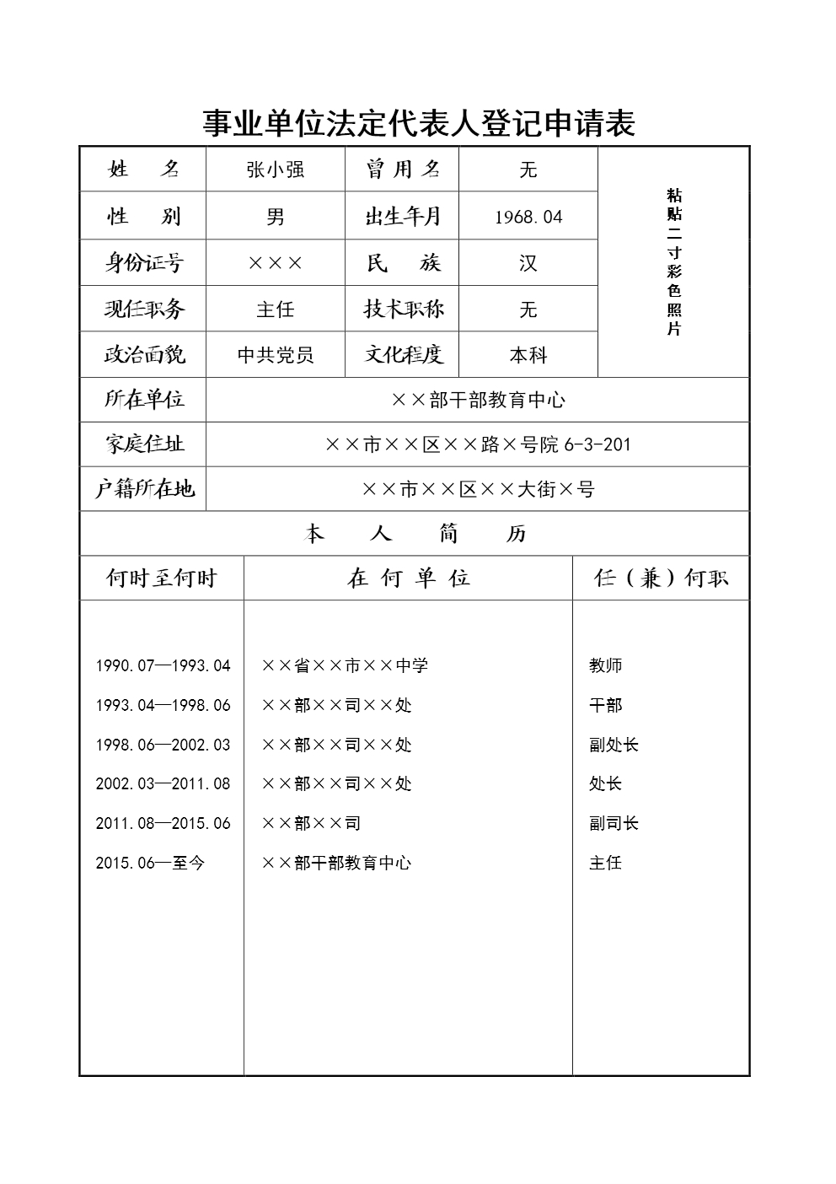](http://www.gjsy.gov.cn/djglsl/201512/W020160531430155824123.jpg)

