[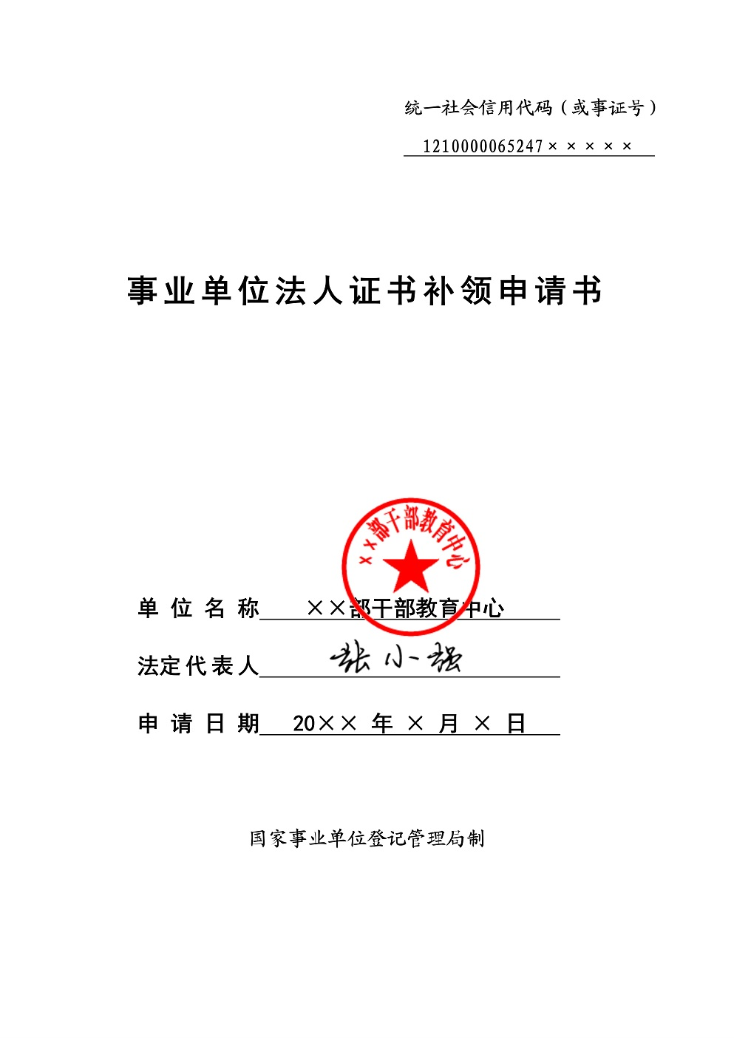](http://www.gjsy.gov.cn/djglsl/201605/W020160531438401635107.jpg)

[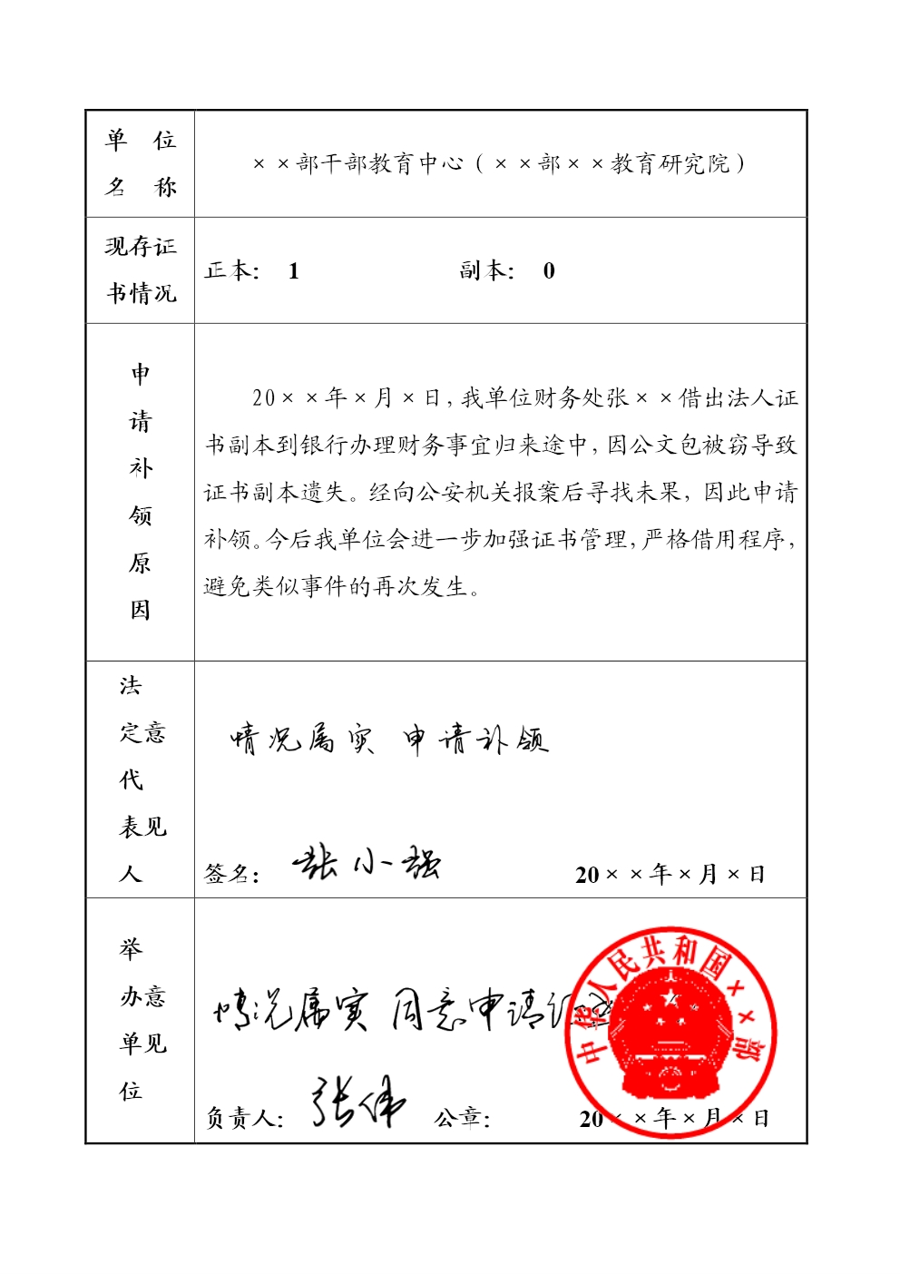](http://www.gjsy.gov.cn/djglsl/201605/W020160531438401640758.jpg)

